1).
create table employee_kc(emp_no varchar (5) primary key,dept_no numeric (2),emp_name char (15),Desig char (15),Basic_sal numeric (10,2),Join_date date,gender char (1) check(gender in('M','F')));

2).
insert into employee_kc
values('E032','20','Vibin','Manager',25000,'11-JUN-96','M');

insert into employee_kc
values('E058','2','Krishnan','Asst. Manager',4000,'10-NOV-99','M');

insert into employee_kc
values('E048','20','Lakshmi','Asst. Manager',5000,'11-Oct-2001','F');

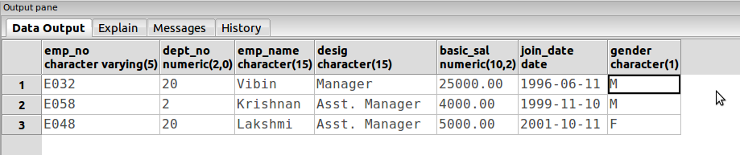

3).
select *
from employee_kc;

4).
select emp_no,emp_name,Desig,basic_sal
from employee_kc;

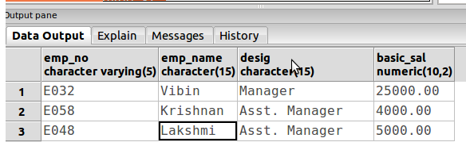

5).
select emp_no ,emp_name
from employee_kc
where dept_no=2;
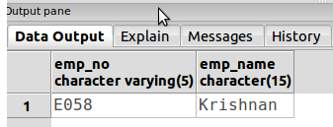

6).
Select emp_no,emp_name,Desig,dept_no,basic_sal
from employee_kc o
order by basic_sal desc;
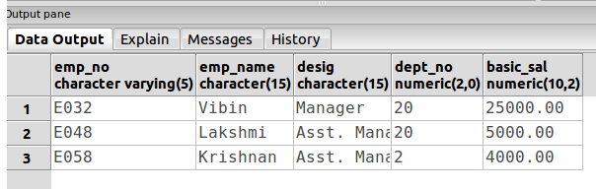

7).
Select distinct Desig
from employee_kc;
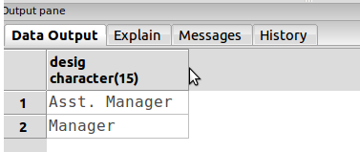

8).
Select emp_no,emp_name,Desig,basic_sal
from employee_kc
order by basic_sal desc,emp_name asc;
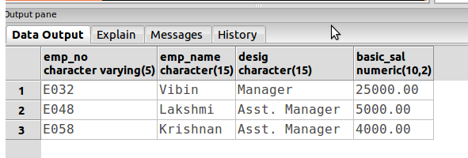

9).
select *
from employee_kc
where Join_date between '01-01-1999'and '12-31-1999';

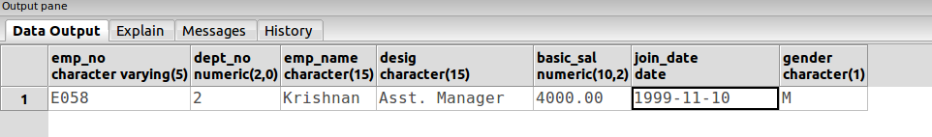

10).
truncate table employee_kc;

alter table employee_kc
alter column dept_no type varchar (20);

select *
from employee_kc;
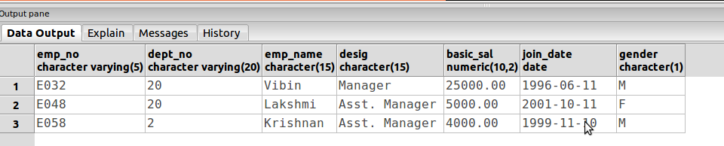

11).
select emp_no,emp_name,Desig,basic_sal
from employee_kc
order by basic_sal desc;
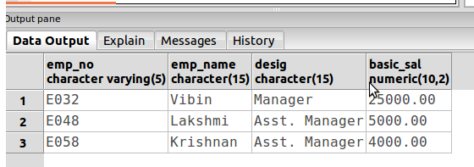

12).
create table emp_contact_kc(eno varchar (5) references employee_kc(emp_no),e_contact numeric (10));

13).
alter table emp_contact_kc
add column address varchar (30);

14).
delete from employee_kc
where basic_sal<5000;

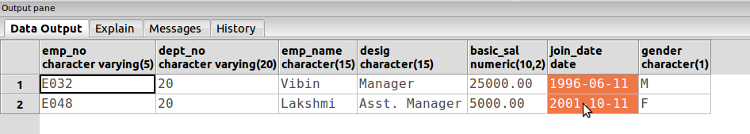

15).
drop table employee_kc;

